Annex 1: Procedures, Notices and Forms

Contents:

Importation of POAO from Third Countries (flow chart) 3

Enforcement Action – Food Not of Animal Origin (flow chart) 4

Enforcement Action – Products of Animal Origin (flow chart) 5

Regulation 32 – Official Feed and Food Controls (England) Regulations 2009 (as amended 6

Regulation 32(6) – Trade in Animals and Related Products (England) Regulations
2011 Notice 9

Regulation 19 – Trade in Animals and Related Products (England) Regulations
2011 Notice 11

Letter of Official Detention 14

Common Veterinary Entry Document (example) 17

Common Entry Document (example) 19

Defra Guidance on the Trade in Animals and Related Products Regulations
2011 21

IIT 1 (4/08) – Report of information about illegal Animal Product Seizures
(example) 24

Importation of POAO
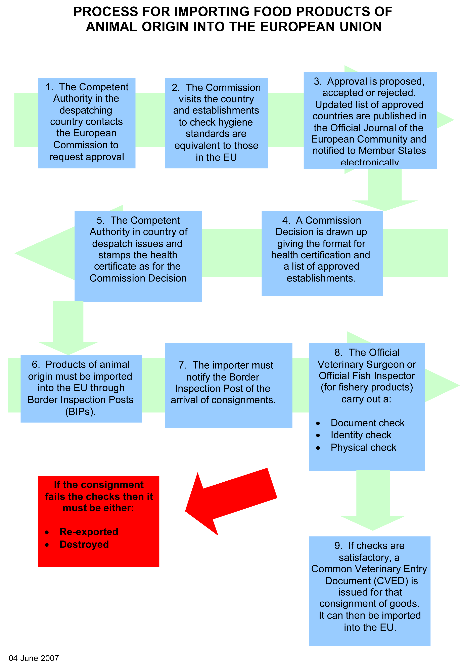
8. The Official Veterinary Surgeon or Official Fish Inspector
(for fish and fishery products) carry out a:

Document Check
Identify Check
Physical Check

Enforcement Action - Food not of Animal Origin
Suspect FNAO

Is this a serious localised incident?

Does the food meet food safety requirements?

Use Regulation 32 OFFC Regs

Voluntary Surrender

ETSF

Other Food Premises

1st Point of Destination Inland
Use only as a last resort
or
No
Yes
Yes
No
No further action
No
Yes
Inform Point of Entry if you believe there was a problem at the time of entry
Inform Point of Entry if you believe there was a problem at the time of entry

If necessary, detain and formally sample using Section 9, FSA 1990
Has controlled FNAO been illegally imported?

No further action
Inform Food Standards Agency
as soon as possible

Enforcement Action - Products of Animal Origin
Yes
No further action
Suspect POAO

Other Food Premises
1st Point Destination Inland

ETSF

Has the food been illegally imported?
Yes

Has the food been illegally imported?
If necessary, detain food using the letter of official detention (Article 65(3))
No
Does the food meet food safety requirements?

No
YES

Serve a Regulation 32(6) TARP Regs
No

Voluntary Surrender
Seize under Section 9 Food Safety Act Order 1991
or

Seize under Reg 19 of TARP Regs

Inform HMRC/UKBA and Defra

No further action
No
Yes
Inform Food Standards Agency as soon as possible
Is this a serious localised incident?
- Complete and return illegal POAO seizures notification form to Defra for Regulation 19 notices only
- Forward copies of all notices to Defra
- Inform Border Inspection Post if you believe a problem existed at time of entry

Notice Ref No:
Authority logo

Regulation 32 Official Feed and Food Controls (England) Regulations 2009 (as amended)

NOTICE FROM [NAME] PORT HEALTH / LOCAL AUTHORITY
The Official Feed and Food Controls (England) Regulations 2009 (as amended)
NOTICE OF
<DETENTION>
<DESTRUCTION>
<SPECIAL TREATMENT>
<RE-DISPATCH>
<OTHER APPROPRIATE MEASURES>
(Note: delete non applicable option/s)

To: Insert importers / person in control of food name/address

I, being an authorised officer of [name] Port Health / Local Authority after consultation with you being the Importer or food business operator, hereby give notice to you in accordance with regulation 32 of The Official Feed and Food Controls (England) Regulations 2009 (as amended) that:-

I suspect that* The consignment described in the schedule below fails to comply with food law <and is injurious to human or animal health or unsafe>* in that:

Insert analyst's / food examiner’s findings including the regulations breached

AND

The consignment is hereby placed under official detention until further notice

I hereby require you to: - either*

< Destroy the food within 60 days of the date stated on this notice > or

< Subject the food to the following special treatment within 60 days of the date stated on this notice >

<insert special treatment> or

<Re-dispatch the feed or food outside the Community within 60 days of the date stated on this notice>

Note that failure to re-dispatch the consignment within the specified time period may result in its destruction under the provisions of Article 69 of Regulation 2017/625 unless a delay is justified.

or
< Take the following other appropriate measures within 60 days of the date stated on this notice>

<insert appropriate measures>

(Note:* delete non applicable option/s)
I hereby require the re-dispatch of the food to a country outside the European Economic Area within 60 days of the date of this notice
The consignment is officially detained pending compliance with the terms of this notice at:

Insert address of where the consignment is being officially detained

SCHEDULE

Product Description
(to include airway bill/bill of lading if applicable):

Container (if applicable):

Vessel (if applicable):

Quantity/Number of pieces: | Total | «quantity» | Gross/Net Weight | «weight» Kg
Importer/Food Business Operator:

Lot Number/s (if applicable):

SIGNED ………………………………………. [AUTHORISED OFFICER]

Name in capitals: Insert officer name/ title

Date: <date>

Address: [Name] Local Authority/Port Health Authority
[Address]

Tel No: [Tel]

Please read the following notes carefully. If you are not sure of your rights or the implications of this notice, you should seek legal advice.

NOTES

The Official Feed and Food Controls (England) Regulations 2009 (as amended)

- Any person who is aggrieved by the decision of an authorised officer to serve a notice may appeal to a Magistrates’ Court, which shall determine whether or not the notice was lawfully served or technically correct.

- If you intend to appeal an application by way of Complaint, an order must be made to the Magistrates Court addressed to the Justice’s Clerks Office, [Address], within one month from the date on which the Notice was served.

Any person who breaches the terms of the notice shall be guilty of an offence and liable on summary conviction to a fine not exceeding the statutory maximum or on conviction on indictment to imprisonment for a term not exceeding two years, to a fine or to both.

In accordance with Article 66, 67 and 69 of Regulation 2017/625, you as the food business operator are responsible for the consignment or product, may be required to pay or reimburse on demand the costs incurred pursuant to this notice including those of storing, transporting, re-dispatching, disposing of and destroying the product or consignment specified in the schedule hereto.

Please note: This template notice is specific to the Official Feed and Food Controls (England) Regulations 2009 (as amended) and will require adaptation for use in Scotland, Wales and Northern Ireland.

Notice Ref No:

Regulation 32(6) Trade in Animals and Related Products (England) 2011 Notice
[Insert Name, address and telephone number of Authority]

REGULATION 32(6) NOTICE

THE TRADE IN ANIMALS AND RELATED PRODUCTS REGULATIONS 2011
(“the Regulations”)

DETENTION OF PRODUCTS OF ANIMAL ORIGIN WHICH MAY HAVE BEEN INTRODUCED IN BREACH OF THE REGULATIONS

TO (Person appearing to have charge of the products): [insert name]

OF: [insert full postal address and postcode]

Country of origin:

Country arriving from (if different to country of origin:

Identifying number (of container/airway bill etc):

I, being an authorised officer of [insert authority] acting under regulation 32(6) of the above Regulations hereby give notice to you, being the person appearing to me to have charge of the consignment or products described in the schedule overleaf, that I am detaining the products listed in the product details schedule overleaf until a Customs officer takes charge of them, because I consider that they may have been introduced into England in breach of the Regulations.

Signed: _____________________________________________

Dated this ________________ day of _____________________ 20__

Name (in BLOCK LETTERS) ______________________________________

Title/Position Held: ___________________________________________

Official Address: (if that different to address at the head of this Notice)

______________________________________________________________

Telephone number: (if different to number at the head of this Notice): _________________

Authority logo
Notice Ref No:

REGULATION 32(6) NOTICE

THE TRADE IN ANIMALS AND RELATED PRODUCTS REGULATIONS 2011
(“the Regulations”)

DETENTION OF PRODUCTS OF ANIMAL ORIGIN WHICH MAY HAVE BEEN INTRODUCED IN BREACH OF THE REGULATIONS

Product Details Schedule

Product Details

 | Description (to include weight and other details e.g. airway bill/bill of lading if known) | Date and time detained by Local Authority | Date and Time notified to Customs | Storage location | Date and time Customs attended
1

2

3

4

Please note: This template notice is specific to the TARP (England) Regulations 2011, and will require adaptation for use in Scotland, Wales and Northern Ireland.

Notice Ref No:
Authority logo

Regulation 19 Trade in Animals and Related Products (England) Regulations 2011 Notice

THE TRADE IN ANIMALS AND RELATED PRODUCTS REGULATIONS 2011

NOTICE UNDER REGULATION 19: UNCHECKED CONSIGNMENTS

TO:

Address:

1. I, being *[an authorised officer for *[local authority]/[an official veterinary surgeon] [Department of Environment and Rural Affairs/Food Standards Agency] acting under regulation 19 of the Trade in Animals and Related Products Regulations 2011 (the “TARP Regulations”), hereby give notice to you, being *[the person appearing to me to have charge of the consignment or product/the person responsible for the consignment or product] described in the Schedule below, that this consignment has been,

*(i) brought into England other than through a Border Control Post approved for that animal or product;

*(ii) removed from a Border Control Post without a CHED or the authority of the Official Veterinary Surgeon at the Border Control Post;

*(iii) transported from the Border Control Post to a destination other than that specified in the CHED.

2. I further give you notice that I am seizing the said consignment or product and I am going to in accordance with Regulation 20(3) -

*(a) dispose of the consignment as Category 1 material in accordance with Regulation (EC) 1069/2009 of the European Parliament and the Council; or

*(b) where health conditions permit, require you to re-dispatch the product outside of Great Britain from the same Border Control Post to a destination agreed with you, using the same means of transport, within a maximum time limit of 60 days; or

*(c) if (b) above is not possible or the time limit has expired or if you agree to do so, destroy the product(s).

- Words and phrases used in this Notice bear the same meaning as they do in the TARP Regulations.

Dated this .................day of....................

Signed ......................................................................
Name (caps) ......................................................................
Position held ......................................................................
Official address ......................................................................

* Delete as applicable

Schedule

Type of Product

Description of Product

Quantity

Weight

Official Certificate reference no.

CHED reference no.

Country of Origin

Other information (e.g. airway bill/bill of lading no. if known)

Please read the following notes carefully. If you are not sure of your rights or the implications of this notice, you should seek legal advice.

NOTES

THE TRADE IN ANIMALS AND RELATED PRODUCTS REGULATIONS 2011

Under regulation 24 of the TARP Regulations any person who is aggrieved by a decision referred to in regulation 20 may appeal within one month of the date of this notification, by way of complaint for an order to a Magistrates’ court.

In accordance with Article 67, 67 or 69 of Regulation 2017/625, you as the food business operator responsible for the consignment or product, may be required to pay or reimburse on demand the costs incurred pursuant to this notice including those of storing, transporting, re-dispatching, disposing of and destroying the product or consignment specified in the schedule hereto.

Letter of official detention

REGULATION 2017/625, Article 65 Ref No:
The Official Controls (Animals, Feed and Food) (England) Regulations 2006

OFFICIAL DETENTION
To:

At:

I am writing to inform you that the food listed in Schedule 1 overleaf has been placed under official detention in accordance with the provisions of Article 65, Regulation 2017/625 and {delete as applicable};
- Must not be removed from its current location at: {insert current location of food}

- Has been removed to: {insert address where food has been removed to}

pending the results of official controls because: {insert the reason why the food has been placed under official detention}

The food listed in Schedule 1 overleaf must not be placed on the market until you have been provided with written confirmation from the food authority that it is acceptable to do so.
Signed ...................................................................... Date ..../..../......
Name (caps) ......................................................................
Position held ......................................................................
Address of food authority ......................................................................
REGULATION 2017/625, Article 65
The Official Controls (Animals, Feed and Food) (England) Regulations 2006

OFFICIAL DETENTION
Schedule 1
The food which is subject to this official detention is described in the table below:

Name of food / Country of Origin | Description of product | Quantity | Date/Further details (e.g. lot code/airway bill/bill of lading)

REGULATION 2017/625, Article 65
The Official Controls (Animals, Feed and Food) (England) Regulations 2006

OFFICIAL DETENTION
Notes:
- Failure to comply with the terms of this official detention may be regarded as an obstruction of the authorised officer and may result in further formal action being taken by the food authority.
- If you believe that you have been unfairly treated by the authorised officer, you may contact his/her manager at the following address:

{insert appropriate contact details}

Common Health Entry-P Document (example)

Common Health Entry Document - D (example)

Defra guidance on the Trade in Animals and Related Products (TARP) Regulations 2011

Intended audience

This guidance is for use by the responsible inspection and control bodies – including local authorities within England that are responsible for enforcement of imported food inland. to explain key elements of the Trade in Animals and Related Products Regulations 2011, S.I. 2011 No. 1197 (‘TARP Regulations’) and how those Regulations are applied and fit with other existing domestic legislation.

Purpose and Legal Status

This guidance is applicable in England only and provides advice on compliance with the requirements of the TARP Regulations that give effect to legislation concerning the importation of animals and animal products from third countries.

Relevant domestic and EU retained legislation

The Official Feed and Food Controls Regulations (England) 2009, S.I. 2009 No. 3255

The Official Controls (Animals, Feed and Food) (England) Regulations 2006 SI 2006 No. 3472

The Trade in Animals and Related Products Regulations 2011, S.I. No. 1197

Regulation (EU) 2017/625 of the European Parliament and of the Council of 15 March 2017 on official controls and other official activities performed to ensure the application of food and feed law, rules on animal health and welfare, plant health and plant protection products, amending Regulations (EC) No 999/2001, (EC) No 396/2005, (EC) No 1069/2009, (EC) No 1107/2009, (EU) No 1151/2012, (EU) No 652/2014, (EU) 2016/429 and (EU) 2016/2031 of the European Parliament and of the Council, Council Regulations (EC) No 1/2005 and (EC) No 1099/2009 and Council Directives 98/58/EC, 1999/74/EC, 2007/43/EC, 2008/119/EC and 2008/120/EC, and repealing Regulations (EC) No 854/2004 and (EC) No 882/2004 of the European Parliament and of the Council, Council Directives 89/608/EEC, 89/662/EEC, 90/425/EEC, 91/496/EEC, 96/23/EC, 96/93/EC and 97/78/EC and Council Decision 92/438/EEC

Key elements

- Relevant provision of The Official Feed and Food Controls Regulations 2009:
- Regulation 3 (3) and Schedule 5 provide that the food authority is designated as the competent authority for the purposes of the provisions of Regulation 2017/625 set out in that Schedule in so far as those provisions apply in relation to relevant food law.

Relevant provision of The Official Controls (Animals, Feed and Food) (England) Regulations 2006 SI 2006 No. 3472:

Regulation 5 provides that the local authority or food authority is designated as the competent authority in relation to enforcement and execution under relevant legislation.

- Relevant Provisions of Trade in Animals and Related Products Regulations 2011:

- Regulation 19

The enforcement authority must seize any consignment—

- brought into England other than through a border inspection post approved for that animal or product;

- removed from a border control post without a HCED-P or the authority of the official veterinary surgeon at the border control post; or

- transported from a border inspection post to a destination other than that specified in the CHED-P

- Regulation 20(3)

If a consignment of products is seized outside a border inspection post under regulation 19, the enforcement authority must –

- dispose of the consignment as Category 1 material in accordance with Regulation (EC) No. 1069/2009, or

- act in accordance with sub-paragraph (b) or (c) of paragraph (1).

- Relevant Provisions of Regulation 2017/625:

Article 45

Under this Article the general rules of Articles 1(2), 44, 66(1),(3)and (5), 67, 68, 69, 71(1) and (2), 72(1)and (2), 137, 138 and 144 of Regulation 2017/625 shall also apply to official controls on all feed and food, including feed and food of animal origin.

Article 65

This Article provides that in case of suspicion of non-compliance or if there is doubt as to the identity or the actual destination of the consignment, or as to the correspondence between the consignment and the certified guarantees, the competent authority shall carry out official controls in order to confirm or to eliminate the suspicion or doubt.

The competent authority may place the consignment concerned under official detention until it obtains the results of such official controls.

Article 66(7), 67 and 69(4)

The feed or food business operator responsible for the consignment or its representative shall be liable for the costs incurred by competent authorities for the activities referred to in Articles 18, 19, 20 and 21.

Article 28

This Article provides for the recovery of expenses arising from additional official controls when the detection of non-compliance leads to official controls that exceed the competent authority's normal control activities. The competent authority can then charge the operators responsible for the non-compliance or may charge the operator owning or keeping the goods at the time when the additional official controls are carried out, for the expenses arising from the additional official controls.

Detention/seizure of POAO inland

Where an officer wishes to detain any product of animal origin inland in order to investigate further to establish its safety or compliance, voluntary co-operation should be sought in the first instance. In situations where this is not possible or is inappropriate due to risk, there are provisions under regulation 19 and 32(6) of the TARP Regulations to detain the product until such a time as the investigation is complete.

Where an authorised officer is satisfied that a POAO has been illegally introduced, they should take appropriate action as outlined in regulation 19 and regulation 20(3) of the Trade in Animals and Related Products (TARP) Regulations 2011. An authorised officer should seize the consignment or product and either:

- Have it re-dispatched, by the mode of transport by which it was first introduced into the EU, to a destination outside the EU, within 60 days,
or
- Have it dispatched for rendering or incineration as category 1 material in accordance with relevant animal by-products legislation.

Although the final decision rests with the enforcing authority, in most circumstances it is unlikely to be appropriate or practical to re-dispatch the products. However, if re-dispatch is appropriate this would need to be carried out through the relevant importer and subject to appropriate control.

IIT 1 (4/08) – Report of Information about illegal Animal Product Seizures (example)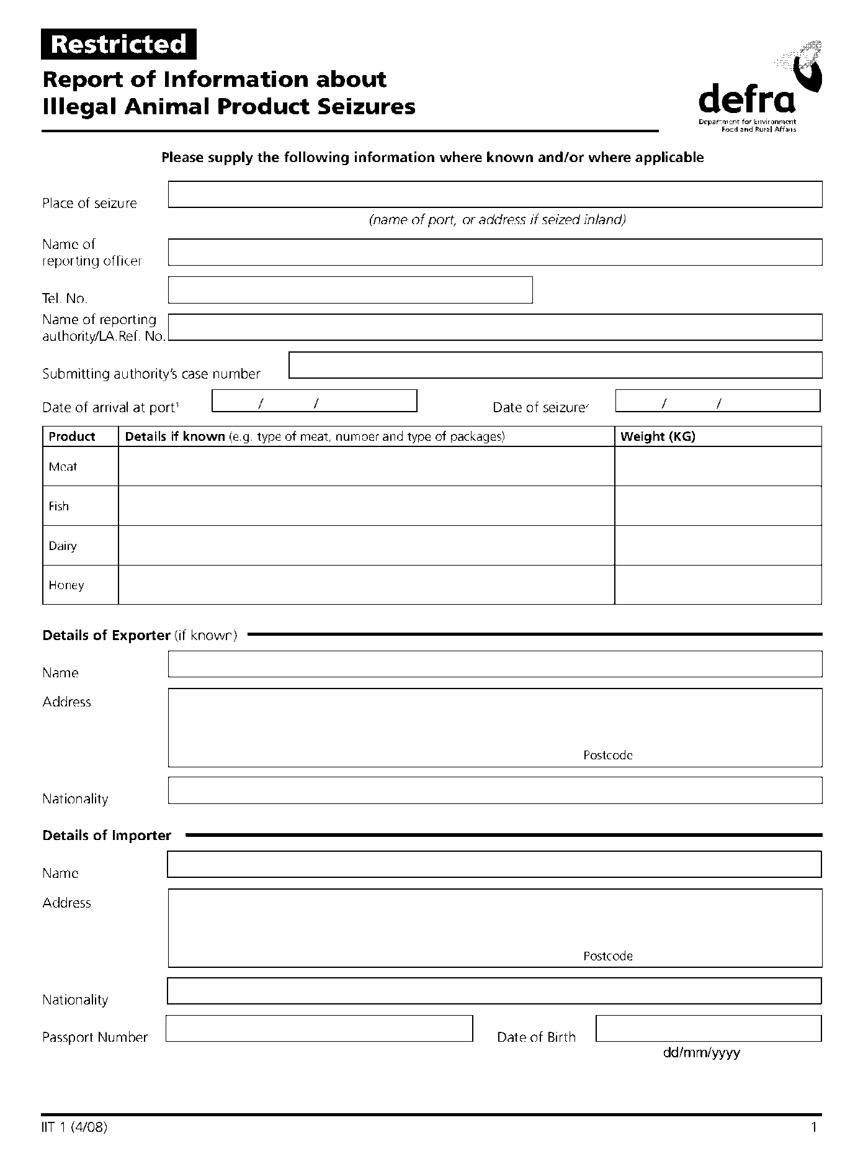

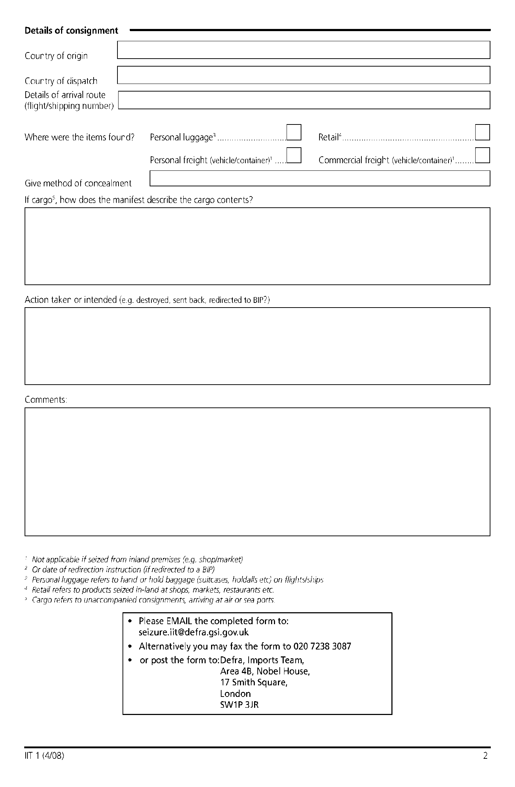

person appearing to have charge of the consignment or product listed in the schedule/person responsible for the consignment or product listed in the schedule.
Insert the name of the person who appears to be in charge of the food.
Insert the address of the food business

